EXP NO 4: Create A Simple Cloud Software Application For Car Booking Reservation System Using Any Cloud Service Provider To Demonstrate Saas.
AIM:
To Create a simple cloud software application for Car Booking Reservation System using any Cloud Service Provider to demonstrate SaaS.
PROCEDURE:
step1: Go to zoho.com.
step 2: Log into the zoho.com.
step 3: Select one application step.
step4: Enter application name as Car Booking Reservation System.
step 5: Created new application as Car Booking Reservation System.
step 6: Select one form.
step 7: The software has been created.
Output:
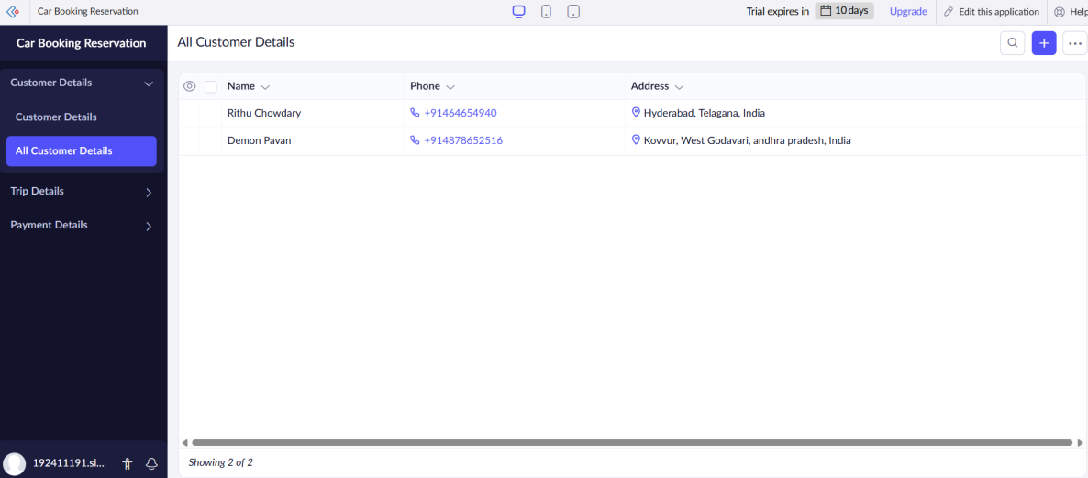
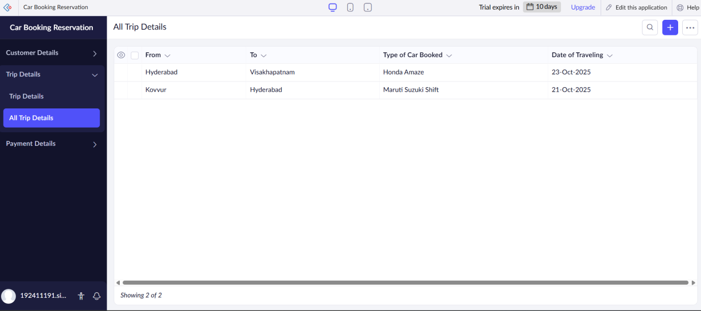
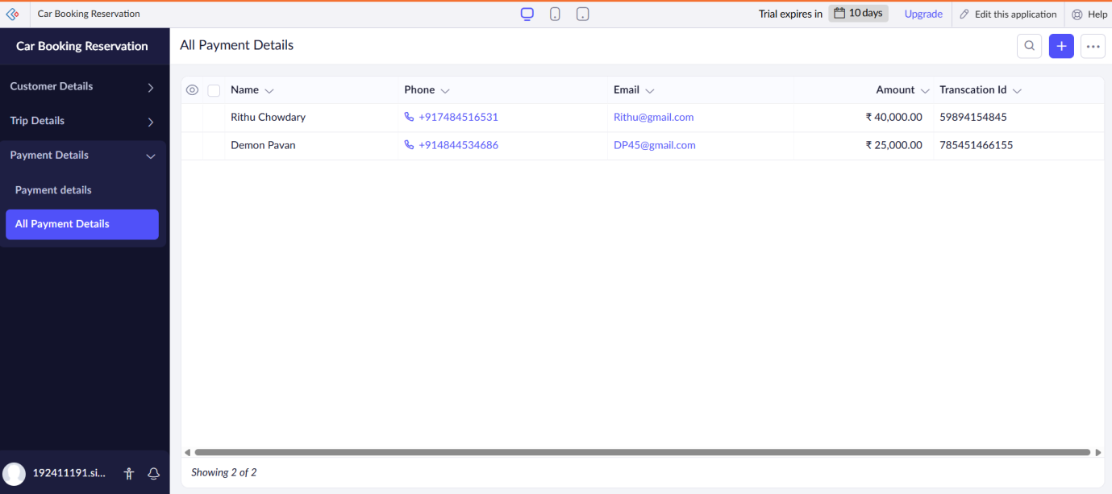

Results:
A simple cloud software application for Car Booking Reservation System using any Cloud Service Provider to demonstrate SaaS.

